A guide for the success of council and district activities and events.



**SENECA WATERWAYS COUNCIL**

Activity and event Planning Guide

GOAL: To providing every youth member a safe, meaningful and fun activity that will lead to growth, character development and lasting memories.

**Table of Contents**

1 Introduction 1

1.1 Purpose of the Guide 1

1.2 Who Can Benefit from This Guide? 1

1.3 Key Features 2

1.4 Event Qualification and Approval Process Work-flow 2

1.5 Event Approvals and Cancelations 3

1.6 Event Success 3

1.7 How to Use This Guide 3

2 Roles 4

2.1 Event Chair 4

2.2 Council or District Activities Committee 4

2.3 Staff Advisor/Scouting Professional 5

3 9 Step Process of Conducting and Event or Activity 6

3.1 Step 1: Goal Setting 6

3.2 Step 2: Logistics 7

3.3 Step 3: Authorization 8

3.4 Step 4: Backdating 9

3.4.1 Activity Backdating template 9

3.4.2 Training Event Backdating 11

3.5 Step 5: Budget 13

3.6 Step 6: Promotion 14

3.6.1 Marketing Plan 14

3.7 Step 7: Staffing 16

3.8 Step 8: The Event 17

3.9 Step 9: Wrap-up 18

3.9.1 Revenue and Field Receipts 18

3.9.2 Purchasing / Expenses 18

3.9.3 Expenses Greater Than Income 20

3.9.4 Income is Far Greater Than Expected 20

4 Appendix A: Planning Worksheet 21

5 Appendix B: Budget Template 22

6 Appendix C: Backdating Template 23

6.1 Activity Backdating Template 23

6.2 Training Event Backdating Template 25

7 Appendix D: NCAP Check-list 27

8 Appendix E: Close-out Report Template 30

9 Appendix F: Safety Guidelines 31

10 Appendix G: Resources 32

11 Appendix H: Short-Term Camp Director Pledge 33

# Introduction

Welcome to the Activity and Event Planning Guide for the Scouting America, Seneca Waterways Council.

There is an axiom that 75% of Scouting is “outing”. However, since some activities may take place inside, a more inclusive term is used herein: “event”.

This guide is crafted to support our dedicated leaders, volunteers, and Scouts in organizing safe, engaging, and fun activities. Whether you are planning a training event, a community service project, or a large-scale camporee, this guide is designed to help you every step of the way.

## Purpose of the Guide

The primary purpose of this guide is to provide the activity committee chairperson with a structured approach to planning and executing and event that embody the values and objectives of the Scouting America. Our aim is to ensure that every event fosters personal growth, community service, and/or the development of essential skills in a safe and supportive environment.

## Who Can Benefit from This Guide?

This guide is an invaluable resource for:

* **Council and District Scouters and Leaders** who are responsible for planning and leading outings and special events.
* **Scout Volunteers and Parents** looking to contribute to the organization and success of Scout activities.
* **Event Coordinators** tasked with organizing district-wide or council-wide events such as camporees, jamborees, and merit badge fairs.
* **Scouts** eager to take on leadership roles and assist in planning activities for their peers.

## Key Features

Our guide includes a variety of features to assist in planning and executing exceptional events:

* **Comprehensive Planning Process:** Step-by-step guidance covering all aspects of event planning, from initial brainstorming to post-event evaluation.
* **Customizable Templates and Checklists:** Practical tools to help you stay organized and ensure that all necessary steps are taken.
* **Safety Guidelines and Best Practices:** Essential information to ensure the safety and well-being of all participants.
* **Resource Listings:** Recommendations for materials, venues, and contacts that can enhance the quality and impact of your events.
* **Evaluation Tools:** Methods for assessing the success of your events and gathering feedback for continuous improvement.

## Event Qualification and Approval Process Work-flow

The following flowchart depicts the stages through which an activity or event is proposed, qualified and approved.

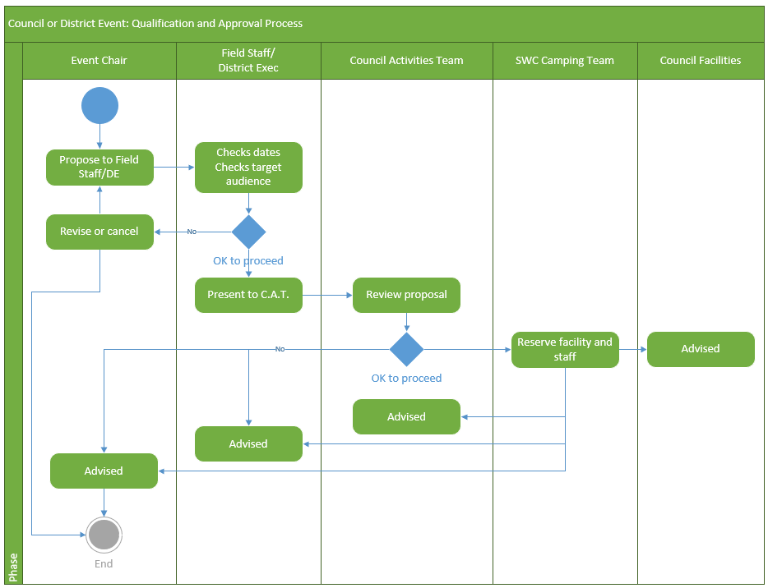

## Event Approvals and Cancelations

All events, district or council, is at the discretion and approval of the Seneca Waterways Council Executive Board. Events not complying with standards may result in an activity being not approved or cancelled. While cancellations of budgeted events should be avoided unless absolutely necessary, a recommendation to cancel a district event must go through the District Chair and District Executive for possible council approval. A council event must go through the staff advisor and council activity committee for approval.

## Event Success

The total financial health of the council relies on the financial success of all events and activities, which comprise the council budget. Therefore, each activity must be self-sustaining. The procedures included in this manual help to assure the success of the event and assure participants of activities that their funds are being used properly and for the purpose intended.

## How to Use This Guide

To make the most of this guide, follow these steps:

1. **Define Your Objectives:** Clearly identify the goals and intended outcomes of your event or activity.
2. **Gather Inspiration:** Explore the activity ideas and resources provided to spark creativity and innovation.
3. **Plan Meticulously:** Utilize our templates and checklists to detail every aspect of your event, from logistics to program content.
4. **Execute with Excellence:** Implement your plan with confidence, knowing you have a comprehensive guide to support you.
5. **Evaluate and Improve:** After the event, use our evaluation tools to collect feedback and reflect on what worked well and what could be improved.

The Seneca Waterways Council is committed to empowering our Scouts and leaders to create memorable and impactful experiences. Let this guide be your trusted companion as you embark on your planning journey, ensuring every event upholds the principles and spirit of the Boy Scouts of America. Happy planning and Scout on!

# Roles

## Event Chair

The role of the Volunteer Chair is to plan, organize, promote, and marshal all the resources necessary to run the event. These responsibilities include:

* Select, recruit, and train key staff (including providing job descriptions / expectations, staff recognition, and follow up to see that jobs are being completed)

NOTE: Some positions require next level approval – consult your Scouting Professional.

* Preside at event staff meetings.
* Promote the event to increase attendance.
* Oversee, with Scouting Professional, the overall event details (e.g., location, date, budget, timeline, theme, program, patches, t-shirts, other recognition items, registration forms/event fliers, promotion, facilities).
* Complete the event diary and post-event evaluation (How did we do? Did we stay within our budget? What went well? What went wrong? What can we do better and how? Who might make a good chair for next year?).
* Reporting progress (Council or District Activities Committee, Scouting Professional, others depending upon activity/event).
* Writing thank you notes.
* Preside and contribute to event Wrap-Up meeting.

## Council or District Activities Committee

The Council or District Activities Committee is a body of Scouters who are responsible for ensuring our council provides great program for our members at all levels of Scouting. It works to:

* Ensures there is sufficient quantity of program for all branches of Scouting in our Council/District.
* Ensures the quality of each event so that participants get the most out of the event.
* Analyzes the timing of events and activities to minimize competition for attendees.
* Ensures that each of the planning steps are completed.
* Periodically meets with the Event Chairman to verify that the planning and execution is on-time, on or under budget, and to mentor the event chairman and event team to maximize the outcome of the event.
* Guides the event chairman in backdating process.
* Aids in the event wrap-up evaluation.

## Staff Advisor/Scouting Professional

The Scouting Professional’s role (serving as District Executive or Staff Advisor) is to advise, assist, and sometimes approve, especially in the areas of scheduling, budgeting, and coordinating the resources of the Seneca Waterways Council. Expectations:

* Working with the Event Chair:
  + Determine Scope and Purpose – Does Event Align with Council and District Goals?
  + Establish Attendance Goal and Target Audience
  + Design and Gain Approval of Event Budget
* Responsible for Collection and Distribution of Funds (registration and payment of expenses)
  + ALL revenue must be entered into the accounting system of the Council Office, and any expenses paid out of the accounting system of the Council Office
  + Must approve all expenses before purchases are made
* Must approve location and site for all activities outside of Council properties
* ONLY a Scouting Professional may enter into an agreement on behalf of a District or Council
* Responsible for properly Backdating the tasks required for a successful event
* Should be present during the event, establishing a schedule with the Event Chair for times when attendance during the event is not possible due to other obligations
* Is always available by phone during the event when not present
* Is not responsible for a specific program area so that they are free to respond to needs
* Attend and help guide event Wrap-Up meeting following event

# 9 Step Process of Conducting and Event or Activity

The 9 Step process is designed to guide the Event Chairman and Event team through the planning process so that the event is as successful as possible. Use the Event planning worksheet as you walk through the planning steps and document the components.

## Step 1: Goal Setting

For an event to be successful, goals must be established. We want to define what success for an event looks like.

**Vision**: What is the picture of success for the event?

**Attendance**: Every event should have an attendance goal and a target audience. Who you want to attend is as important as how many. This will help focus marketing and promotion.

**Program**: A program goal can be thought of as the answer to the question: “Why are we doing this event?” Program goals help to keep focus on the purpose of the event. Limit program goals to three or less; any more starts to get too complicated and spreads resources and attention too thin. Your program goal gives you something to measure all other tasks against.

**Financial**: Processing registrations and fees for an event are important services provided by the Seneca Waterways Council staff. This allows volunteers to focus on program and not administration.

***Every activity with expenses must have income in the form of activity fees. (Marketing and outreach activities may be an exception.)***

***A budget for any event must be developed by the Event Chair and the Scouting Professional. The Council/District Activities Committee can provide consultation to the Event Chair in developing the budget. Budgets must have second level approval of a Field Director or the Director of Field Service before registration and promotion may begin.***

Budgets for events must be submitted during the council budget building process for the following calendar year because they are part of the overall Council Budget. Budgets are to be developed in July, reviewed in August and submitted in September. Un-budgeted events are not allowed. For council level events, a copy of the event planning worksheet and budget shall be sent to the Council Activities Committee and to the V.P. of Program. For district level events, copies of the event planning worksheet and budget shall be sent to the District Activities Chair and to the District Chair.

**Training Events**: It is not required that events for basic training generate excess revenue (money left over after all expenses are paid). If one of these trainings involves extra expenses, such as food or recognition items, then a fee is expected to cover these expenses.

Trainings that fall into this category: Position Specific Training, BALOO, Outdoor Leader Skills for Webelos Leaders, IOLS, District Committee training, or other BSA training provided at the district level.

## Step 2: Logistics

Logistics involves the time, date, and location of an event, as well as the resources needed to support that event like parking, check-in, tenting, and program areas. The availability of a location is a factor when scheduling the time and date. Remember, “the early bird catches the worm.”

**Location**: Every activity site must be approved by the District Executive or Staff Advisor BEFORE any agreement can be made. The Council Activities Committee will review the date and location for any conflicts of target audience and location between this event and other events that are already approved. If no conflict is found, the CAC will provide an NCAP Standard Advisor to review and enforce NCAP standards are being met.

Once the location is approved, the District Executive or Staff Advisor must be the one to sign any contractual agreement. Only a Scouting professional can enter into an agreement on behalf of the council. When securing a location, it is important to speak to both the person authorized to make decisions and the person who will be on-site during the event. This ensures that everyone understands the conditions of the agreement.

**Date**: Look at other calendars in addition to the council calendar before proposing a date. School calendars, community calendars and religious holidays are all important considerations.

Review the date with the Council/District Activities Committee for appropriate timing and target audience. Make sure you have time to develop a budget, gain budget approval, promote and make all other necessary arrangements for any event date you have in mind. If you are planning an event at a council camp, then you want to be certain you are part of the semiannual calendar planning meeting.

Check with council camping before planning to hold an event at any council camp property.

**Time**: Think about how long the event is going to last and the best time to begin. Allow for travel time of your participants, especially when expecting participants from the far side of the council to attend the event. Plan also for time to setup the location for the event and to tear-down and clean-up after the event.

**Parking**: It is important to consider parking vehicles and unit trailers for both staff and participants.

**Certifications**: Some program activities require staff to be trained and carry current certifications. Range And Target Activities (RATA) like Archery, Shotgun and Rifle range officers need to have the proper and current certifications. For example: Scouting America requires an archery range officer to be carry a US Archery Level 1 certification or higher, aquatic activities may require a certified life guard. Check with the Council Activities Committee to determine which, if any, certifications will be required to run the intended program.

**National Camp Accreditation Program (NCAP) Standards**: It is vital when planning an council or district activity or training that NCAP standards will be met. See the NCAP Check-List/Standards at a glance for guidance. The Council Activities Committee will provide an NCAP standard guide to help the Event Chairperson with meeting these standards.

## Step 3: Authorization

The event shall be submitted to the Council Activities Committee for approval. The Council Activities Committee will review the proposed date, location, program and target audience and compare with other council and district events to verify that it fits in strategically with other activities and the event’s target audience.

Any day camp, activity or training event that has an overnight component must have a trained Short-Term Camp Administrator assigned to it. The administrator will work with the event chair to make sure that the event is following all BSA procedures so that the event will be compliant with the Scouting America National Camp Standards. It is especially important to work with the Short-Term Camp Administrator if the event is looking to add new activities.

Every Short-Term Camp Director (day camp, activity or training event) must sign the Short-Term Camp Director Pledge which outlines their responsibilities and important council guidelines.

## Step 4: Backdating

Backdating is a method used by the Scouting America to plan and organize events. This method takes the action items necessary for success and places them in chronological order, providing a deadline for completion of each task. This process helps avoid missed promotion opportunities important to success. Below is a sample back-dating table. Use it as a starting point for your activity and adjust as necessary.

The backdating plan works in conjunction with the council budgeting plan. Read the budgeting section for additional details.

### Activity Backdating template

|  |  |
| --- | --- |
| Prior to final council budget | Task |
| Prior to Aug 15th of preceding year | Recruit event leader  Propose event location, program objectives and needs  Estimate event budget  Present to CAC and get Event approval  Add to Council calendar  Reserve facilities |

|  |  |
| --- | --- |
| Backdate in days | Task |
| E-150 days | Preliminary planning meeting  Submit revised plans to CAC, Staff Advisor and VP Program   1. Staff training needs 2. NCAP confirmation   Develop Promotional Materials  Design Patch(es) and seek needed bids  Start recruiting Event Committee members  Submit promotional materials to Staff Advisor for approval  Submit patch design to Staff Advisor for approval |
| E-120 days | 2nd event committee meeting  Begin online registration and online event promotion  Begin early promotion (newsletter & roundtables)  Submit Request to Purchase Forms, Order Patches, Supplies, etc. Distribute Media Releases  Submit Orders for Printing  Attend CAC meeting providing needs and updates |
| E-90 days | Monthly event committee meeting  Finalize Mid-level program and logistics   * + 1. Event activities and rules and signage     2. Confirm / adjust for age-appropriateness     3. Draft Parking, Camping, Traffic Flow   Full-scale promotion Mail Registration Forms to Units, newsletter & roundtable  Attend CAC meeting providing needs and updates |
| E-60 days | Monthly Committee Meeting  Early-bird Registration ends  Order patches  Attend CAC meeting providing needs and updates |
| E-30 | Registration Deadline  Attend CAC meeting providing any last-minute needs |
| E-15-7 | 1. Confirm staffing and assignments 2. Confirm event logistics plan ready to implement 3. Confirm facility readiness |
| E-5 | Final Check on Details |
| E-1 | Event setup   1. logistics    1. parking area designation    2. event check-in point    3. camping area designation    4. first-aid station    5. event signage in place    6. activity setup 2. Final, last-minute facilities check    1. Water    2. Bathrooms |
| 0 | Event Activity Day |
| +7 | Event committee evaluation meeting held   1. Collect & submit final receipts 2. Draft event closeout report    1. Attendance    2. Cost / revenue    3. Goals achieved    4. Issues overcome    5. Event lessons to pass along 3. Return any borrowed or assigned equipment 4. Send “thank-you” letters |
| +14 | 1. Submit revised Event Closeout report to Council Activities    1. Attendance    2. Cost / revenue    3. Goals achieved    4. Issues overcome    5. Event lessons to pass along   Attend CAC meeting to share experience with others |

### Training Event Backdating

**Setup**

|  |  |  |  |  |
| --- | --- | --- | --- | --- |
| Check | Item | Due | Responsibility | Notes |
|  | Set dates and times | February of the prior year | Training Chair, Course Director | Date may be changed up to 6 months out only if absolutely necessary. |
|  | Select facilities | 18 months | Training Chair, Course Director | Consider proper overnight accommodations and internet access needs. |
|  | Reserve facilities | 18 months | Staff Advisor | Or as soon as facility reservations are opened. |
|  | Create a budget | 6 months or December of the prior year. | Training Chair, Staff Advisor | Required before setting price. |
|  | Set pricing | 6 months or December of the prior year. | Training Chair, Staff Advisor | Consider the following variables:  Early/Regular/Late Adult/Youth In/Out of Council Participant/Staff/Kitchen Bring-a-friend discount |
|  | Open registration | 6 months | Staff Advisor | Finalize details in Black Pug. All above items must be complete before opening registration. |

**Promotion**

|  |  |  |  |  |
| --- | --- | --- | --- | --- |
| Check | Item | Due | Responsibility | Notes |
|  | Early-stage Advertising | 6 months | Course Director | “Pull” advertising: Websites, calendars. |
|  | Full-Scale Advertising | 3 months | Course Director | “Push” advertising: Flyers, emails, newsletters |
|  | Identify Candidates | 3 months | Training Chair,  Course Director | Run reports of who needs the training. |
|  | Recruiting | 3 months | Course Director, Course Staff | Direct contact with candidates. |

**Preparation**

|  |  |  |  |  |
| --- | --- | --- | --- | --- |
| Check | Item | Due | Responsibility | Notes |
|  | Review Budget | 3 months | Training Chair,  Course Director |  |
|  | Recruit Staff | 3 months | Course Director |  |
|  | Order Swag | 3 months | Course Director  Staff Advisor | Well in advance to ensure receipt on time. |
|  | Create course agenda | 2 months | Course Director | Make assignments |
|  | Gather equipment and supplies | 2 months | Course Director | Use existing equipment and supplies when possible. |
|  | Staff development | 2 months | Course Director | At least one in-person session. |
|  | Verify participants eligibility | 2 weeks | Training Chair, Course Director | Confirm that registered participants meet pre-requisites |
|  | Send pre-course information to registered participants | 2 weeks | Course Director |  |
|  | Print handouts | 2 weeks | Course Director, Staff Advisor |  |

**Preparation**

|  |  |  |  |  |
| --- | --- | --- | --- | --- |
| Check | Item | Due | Responsibility | Notes |
|  | Take attendance | Course start | Course Director |  |
|  | Verify medical forms | Course start | Course Director |  |
|  | Collect evaluations | Course end | Course Director | Course evaluation and trainer interest form |
|  | Participant recognition | Course end | Course Director | Training cards and/or certificates |

**Closeout**

|  |  |  |  |  |
| --- | --- | --- | --- | --- |
| Check | Item | Due | Responsibility | Notes |
|  | Send post-course information to attendees | 2 days | Course Director |  |
|  | Submit Training Attendance Report (TAR) | 2 weeks | Course Director |  |
|  | Staff recognition | 2 weeks | Course Director |  |
|  | Close budget and expenses | 1 month | Course Director, Staff Advisor |  |

## Step 5: Budget

Each event that brings in or spends money must have a budget. The budget is to be developed by the Activity Chair and the Scouting Professional.

Budgets are completed in the late Summer and Autumn for the following calendar year. The budget will go through a review and approval process. **Adding a new event budget after the official budgeting process for the year requires the Scouting Professional to get approval by the appropriate senior Staff Leader and the Scout Executive.**

**Promotion and registration will not begin, and fliers will not be produced or distributed until an approved budget is in place.**

**Stage 1:** **Expenses:** Building a budget starts with listing expected expenses, using estimated costs that could be a little higher than expected. Estimated expenses should include any shipping, rentals and cleaning supplies. If your event utilizes program areas or buildings at a council camp, there are costs associated with that as well; include these fees in the event expenses.

**Stage 2:** **All budgets must plan for at least a contingency.** To calculate the contingency, multiply the estimated expenses by 15%.

**Stage 3:** **Calculate total estimated expenses.** Add together values for Stage 1 and Stage 2, to determine the total estimated expenses for the event.

**Stage 4: Participant Fee:** Divide the total estimated event expenses by the estimated attendance number to calculate the participant fee. Be conservative! If the event has occurred previously, use 80% of the previous attendance.

**Stage 5:** **Other revenue sources.** Events, like fund raisers, may have other sources of revenue such as sponsorships or donations. Define these opportunities, and then use a conservative estimate for the amount of additional revenue that may be obtained. Be conservative. If the event has occurred before, use 50% of the average past 3 years of additional revenue sources. If this is a new event, use 10% to 30% of the projected opportunities.

A budget worksheet is provided in this guide as a starting point to help you develop your budget.

## Step 6: Promotion

With an approved plan and budget, it is time to get the word out! Help is available through the council Marketing Specialist but the primary responsibility for marketing an event falls to the team running the event. The event chair is responsible for getting the attendance for the event. The council can provide:

* Posting to the council Social Media Accounts
* Providing the event team with Social Media Asset(s) to post on the council and district pages
* Adding the event to the council calendar
* Adding the event to the appropriate area of the council website
* Help developing a marketing plan

The event team, working with the Scouting Professional, may choose to design an event flyer.

**All council level event flyers must be approved by the District Executive or Event Staff Advisor (Scouting Professional). The Event Staff Advisor will submit the flyer to the Marketing Specialist for final approval. Only flyers for budgeted events, with reservations (if using Council property) and established online registration information will be approved.**

Distribute promotional fliers at roundtable, district trainings, and district events.

Event fliers are to be one-page only and should include the date, time, location, a general event description and the event webpage URL for additional details. The event webpage URL may be to the council reservation system or a specific page that has been created for the event.

### Marketing Plan

In Step 1, you identified who you expect to addend your event. NOW it is time to market directly to them. A detailed plan, and executing that plan is crucial to reaching your target audience. The most successful plan puts the exciting and critical information about your event in front of your audience at least 5 to 7 times. Direct mailing (email to save on cost), inclusion in district/council email reminders, Roundtable promotion, unit visitations, websites, social media, phone calls, and personal contacts are all effective promotion strategies.

Don’t just use one…use them all!

All details about district events (e.g., what to bring, program, rules, schedule, contact info) are to be posted on the District Webpage of the Council Website (not as a downloadable document or printed and distributed to leaders) for the following reasons:

* Saves trees
* Decreases the possibility of inconsistent messages distributed in printed guides vs. posted on the event webpage
* Drives target audience to one consistent place
* Content is more obvious on the website when a document doesn’t have to be downloaded, especially for parents
* Friendlier web navigation for desktop and mobile users
* Speeds up access to information for users (documents don’t have to be downloaded)
* Allows for making updates quicker/easier – Scouting Professional can coordinate change with website administrator
* Avoids the “I didn’t see the document” excuse since the information on the site is always available

In order to have your event details posted onto your district’s web page, use the district event details web form. (TBD).

## Step 7: Staffing

Don’t do it alone! Council and District committees can help identify volunteers. The Commissioner Staff and Unit Leaders can provide leads as well. For council level events, members of the Council Program Committee can often help; utilize the Scouting Professional serving as the Staff Advisor to assist with contacts as needed. Volunteers looking to engage community leaders can work with their District Executive or Staff Advisor for networking opportunities.

Typically, event staff is needed for logistics, program, food, health and safety, and backup staff to assist. The Staff Advisor/Scouting Professional serves as the finance chair for the event.

Remember that Council Events (All Training, Special Events, and Program Events) require prospective lead volunteers to be approved. Please gain approval prior to recruiting a volunteer for a position. The Staff Advisor will present the list of prospective event volunteers for approval to the Council Activities Committee and Director of Support Services.

## Step 8: The Event

During the event, the Chair and Scouting Professional (District Executive or Staff Advisor) should not have responsibilities for a specific task. They are responsible for going surveying the event by visiting program areas and ensuring a quality experience for participants. Notes should be taken about things that are great and not-so great. All overnight events and day camps will have a Short-Term Camp Administrator Assess the event while it is occurring.

**For every event – all participants and staff must be checked in with the Council Electronic Registration System and proper safety identification protocols must be followed. Talk to your Scouting Professional for current procedures.**

## Step 9: Wrap-up

After the event, a formal wrap-up meeting occurs. This meeting involves as many members of the event team as possible. The Scouting Professional takes notes about what to continue and what to improve. Wrap-up notes will be included in the event folder.

A Close-out Report is to be completed that will summarize the event (see appendix) and included in the event folder and submitted to the Staff Advisor and the Council/Activities Committee.

Once complete, the Scouting Professional and Chair work together to complete a physical notebook or electronic file with all relevant event information: record of staff members, copies of vendor invoices and purchase orders, the event flyer, event specifics from the website, final budget reflecting actual activity, and notes from the Wrap-Up.

**The Scouting Professional is responsible for closing out the budget in the same month the event takes place. See Purchasing for Events for more guidance about policies on reimbursing volunteers for their out-of-pocket purchases for events.**

### Revenue and Field Receipts

The Event Chair and Scouting Professional are responsible for all expenditures and income:

* All income must go directly to the council office and be receipted to the appropriate account. The council online registration system is to be used for all registrations. Paper registration forms are no longer accepted. Only council accounts are permitted. District bank account, savings accounts or slush funds are not permitted. Field receipts (available from the Scouting Professional) must be issued when taking in monies for an event outside of registrations paid through the council online registration system which provides an email receipt instead.
* Reimbursement of expenses with cash received at an event is not permitted
* The district executive is responsible for turning in all event revenues and allocating it to the proper account

### Purchasing / Expenses

**Total expenses may not exceed the revenue**. Variations from the budget including changes in pricing must be approved by the Event Staff Advisor. Variations will only be approved if participation, therefore income, goes up. Taking into consideration the actual attendance, the expenses budgeted on each line item should not be exceeded. If participation decreases, a revised budget should reflect an adjustment downward accordingly.

* Volunteers should not be required to make purchases for items in an event budget. Every effort should be made for purchases to be made through the council or district purchasing process. Reimbursements are highly discouraged.
* The council has accounts / discounts with several vendors including: Amazon, Oriental Trading Company, Walmart, Home Depot, Lowes, etc. Please work with your Scouting Professional to figure out the most effective vendors to use.
* Preferred Method of Making Purchases: Purchase Orders, originated by the Scouting Professional and issued out of the accounting system of the Council Office are the preferred method of making purchases.
* Secondary Method of Making Purchases: For vendors that do not take Purchase Orders, a Corporate Credit Card or account can be used - an approved PO is still required before the use of the card will be approved.
* Cash Advances: The Scouting Professional may request a cash advance in some extreme circumstances. Cash advances require Staff Leader approval and take 2 weeks to process.
* Tax exemption can be claimed by presenting a NY State Sales Tax exemption certificate (available to the Event Chair from the Scouting Professional).
* **Reimbursements: Purchasing done directly by volunteers is highly discouraged, and purchases made without written approval from the Event Staff Advisor for the event may not be reimbursed. Receipts for approved expenses must be provided to the Event Staff Advisor within 2 weeks of the end of an event to be considered for reimbursement. Once an event is closed out (30 days from the last day of the event) reimbursement will not be issued and the purchase will be considered a donation.**
* The Event Chair and Scouting Professional must inform the event staff about budgetary limits and restrictions. Those approved to purchase event supplies will be informed exactly how much has been budgeted for each area or item. All purchases should be coordinated through the event chair since various areas may require identical items that could be shared to avoid excess materials. Since actual costs may vary from the budgeted amount it is understood that small variances are likely, but substantial variances require a budget adjustment. If one budget item costs more than the budgeted amount, another item will have to cost less. Event chairs must ensure that all event staff purchasing supplies remain within their budget limits.   
  **All expenditures must have a vendor issued original receipt.**
* When ordering items, look for the best values (ask other districts, previous event chairs or at council coordinated meetings) and work within the parameters of budget (must justify costs).
* BSA License: Only use licensed vendors to purchase items such as patches and t-shirts with BSA trademarks (e.g., fleur-de-lis) or that represent the council, district or BSA. Visit www.bsalicensing.org for more information.
  + Determine if a vendor is licensed by visiting <https://scouting.org/sitecore/content/Licensing/Current%20Licensees.aspx> or by emailing licensing@scouting.org (for local companies).
  + Bids: At least three bids are required for larger purchases. Check with the Scouting Professional for when multiple bids are required.

### Expenses Greater Than Income

Sometimes this happens. Perhaps attendance was low or expenses were high. Proper planning done in advance usually eliminates this problem. The purchasing procedures help control over-spending and early promotion helps reduce attendance problems. In rare instances, there may still be enough time to cancel an event. But, should an event lose money, the council covers the losses, but the budget will be closely reviewed and the event’s future will be weighed versus its benefit.

### Income is Far Greater Than Expected

A careful review of the event should pinpoint the reason that income was higher than expected. Usually having higher attendance than planned results in a higher surplus than expected. Sometimes, fees may be set too high and a recommendation for lowering next year’s fees should be made. A decision to accept the recommendation will be made after the event is closed out and all expenses accounted for, council cash flow, and the success of other district events. For instance, a district may show a loss in the district dinner, but the camporee has made up for it. The overall collective income for all activities combined must exceed the expenses.

# Appendix A: Planning Worksheet

The planning worksheet follows the 9-step process outlined above. It is designed to collect the respective information and be easily reviewed by event team members, the staff advisor and the Council/District Activities Committee.

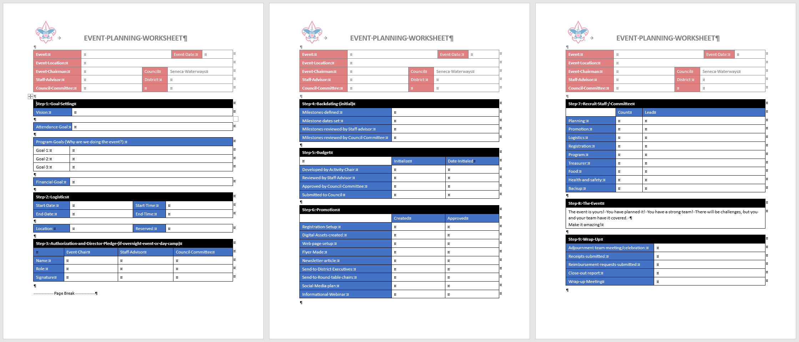

# Appendix B: Budget Template

The budget template is used to develop the budget for an activity or event. It is to be reviewed and approved by the staff advisor and Council/District Activities Committee. For all council events/activities, one is to be submitted and approved prior to the annual budget being submitted to the council board.

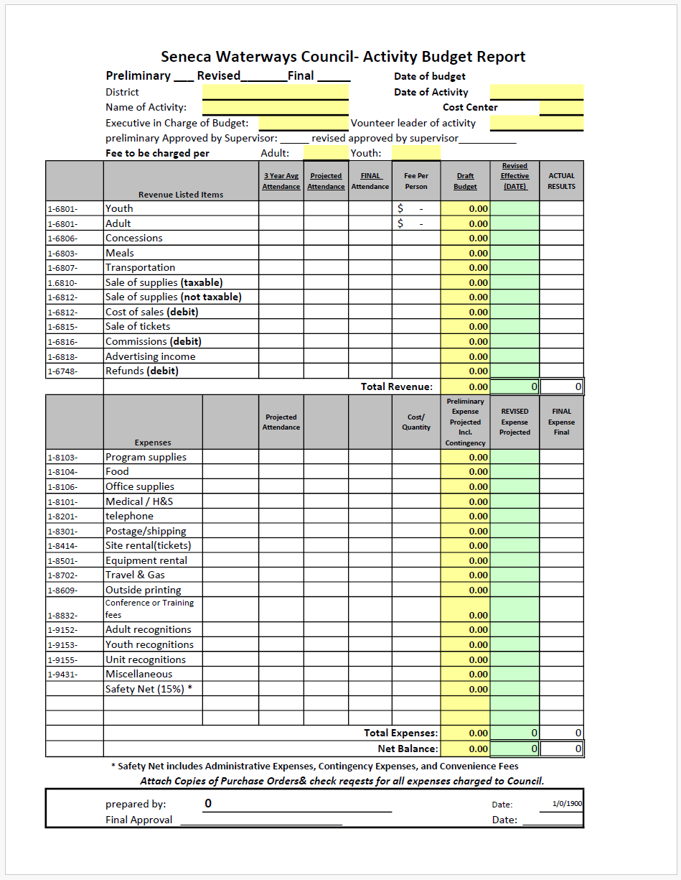

# Appendix C: Backdating Template

The table below provides a list of tasks and the number of days before or after the event that the task is targeted to be completed.

## Activity Backdating Template

|  |  |
| --- | --- |
| Prior to final council budget | Task |
| Prior to Aug 15th of preceding year | Recruit event leader  Propose event location, program objectives and needs  Estimate event budget  Present to CAC and get Event approval  Add to Council calendar  Reserve facilities |

|  |  |
| --- | --- |
| Backdate in days | Task |
| E-150 days | Preliminary planning meeting  Submit revised plans to CAC, Staff Advisor and VP Program   1. Staff training needs 2. NCAP confirmation   Develop Promotional Materials  Design Patch(es) and seek needed bids  Start recruiting Event Committee members  Submit promotional materials to Staff Advisor for approval  Submit patch design to Staff Advisor for approval |
| E-120 days | 2nd event committee meeting  Begin online registration and online event promotion  Begin early promotion (newsletter & roundtables)  Submit Request to Purchase Forms, Order Patches, Supplies, etc. Distribute Media Releases  Submit Orders for Printing  Attend CAC meeting providing needs and updates |
| E-90 days | Monthly event committee meeting  Finalize Mid-level program and logistics   * + 1. Event activities and rules and signage     2. Confirm / adjust for age-appropriateness     3. Draft Parking, Camping, Traffic Flow   Full-scale promotion Mail Registration Forms to Units, newsletter & roundtable  Attend CAC meeting providing needs and updates |
| E-60 days | Monthly Committee Meeting  Early-bird Registration ends  Order patches  Attend CAC meeting providing needs and updates |
| E-30 | Registration Deadline  Attend CAC meeting providing any last-minute needs |
| E-15-7 | 1. Confirm staffing and assignments 2. Confirm event logistics plan ready to implement 3. Confirm facility readiness |
| E-5 | Final Check on Details |
| E-1 | Event setup   1. logistics    1. parking area designation    2. event check-in point    3. camping area designation    4. first-aid station    5. event signage in place    6. activity setup 2. Final, last-minute facilities check    1. Water    2. Bathrooms |
| 0 | Event Activity Day |
| +7 | Event committee evaluation meeting held   1. Collect & submit final receipts 2. Draft event closeout report    1. Attendance    2. Cost / revenue    3. Goals achieved    4. Issues overcome    5. Event lessons to pass along 3. Return any borrowed or assigned equipment 4. Send “thank-you” letters |
| +14 | 1. Submit revised Event Closeout report to Council Activities    1. Attendance    2. Cost / revenue    3. Goals achieved    4. Issues overcome    5. Event lessons to pass along   Attend CAC meeting to share experience with others |

## Training Event Backdating Template

**Setup**

|  |  |  |  |  |
| --- | --- | --- | --- | --- |
| Check | Item | Due | Responsibility | Notes |
|  | Set dates and times | February of the prior year | Training Chair, Course Director | Date may be changed up to 6 months out only if absolutely necessary. |
|  | Select facilities | 18 months | Training Chair, Course Director | Consider proper overnight accommodations and internet access needs. |
|  | Reserve facilities | 18 months | Staff Advisor | Or as soon as facility reservations are opened. |
|  | Create a budget | 6 months or December of the prior year. | Training Chair, Staff Advisor | Required before setting price. |
|  | Set pricing | 6 months or December of the prior year. | Training Chair, Staff Advisor | Consider the following variables:  Early/Regular/Late Adult/Youth In/Out of Council Participant/Staff/Kitchen Bring-a-friend discount |
|  | Open registration | 6 months | Staff Advisor | Finalize details in Black Pug. All above items must be complete before opening registration. |

**Promotion**

|  |  |  |  |  |
| --- | --- | --- | --- | --- |
| Check | Item | Due | Responsibility | Notes |
|  | Early-stage Advertising | 6 months | Course Director | “Pull” advertising: Websites, calendars. |
|  | Full-Scale Advertising | 3 months | Course Director | “Push” advertising: Flyers, emails, newsletters |
|  | Identify Candidates | 3 months | Training Chair,  Course Director | Run reports of who needs the training. |
|  | Recruiting | 3 months | Course Director, Course Staff | Direct contact with candidates. |

**Preparation**

|  |  |  |  |  |
| --- | --- | --- | --- | --- |
| Check | Item | Due | Responsibility | Notes |
|  | Review Budget | 3 months | Training Chair,  Course Director |  |
|  | Recruit Staff | 3 months | Course Director |  |
|  | Order Swag | 3 months | Course Director  Staff Advisor | Well in advance to ensure receipt on time. |
|  | Create course agenda | 2 months | Course Director | Make assignments |
|  | Gather equipment and supplies | 2 months | Course Director | Use existing equipment and supplies when possible. |
|  | Staff development | 2 months | Course Director | At least one in-person session. |
|  | Verify participants eligibility | 2 weeks | Training Chair, Course Director | Confirm that registered participants meet pre-requisites |
|  | Send pre-course information to registered participants | 2 weeks | Course Director |  |
|  | Print handouts | 2 weeks | Course Director, Staff Advisor |  |

**Preparation**

|  |  |  |  |  |
| --- | --- | --- | --- | --- |
| Check | Item | Due | Responsibility | Notes |
|  | Take attendance | Course start | Course Director |  |
|  | Verify medical forms | Course start | Course Director |  |
|  | Collect evaluations | Course end | Course Director | Course evaluation and trainer interest form |
|  | Participant recognition | Course end | Course Director | Training cards and/or certificates |

**Closeout**

|  |  |  |  |  |
| --- | --- | --- | --- | --- |
| Check | Item | Due | Responsibility | Notes |
|  | Send post-course information to attendees | 2 days | Course Director |  |
|  | Submit Training Attendance Report (TAR) | 2 weeks | Course Director |  |
|  | Staff recognition | 2 weeks | Course Director |  |
|  | Close budget and expenses | 1 month | Course Director, Staff Advisor |  |

# Appendix D: NCAP Check-list

NCAP has develop the NCAP Standards At-A-Glance Checklist to help Event Chairpersons, Staff Advisors and the Council/District Activities Committees plan and verify that standards are being met for Scouting activities.

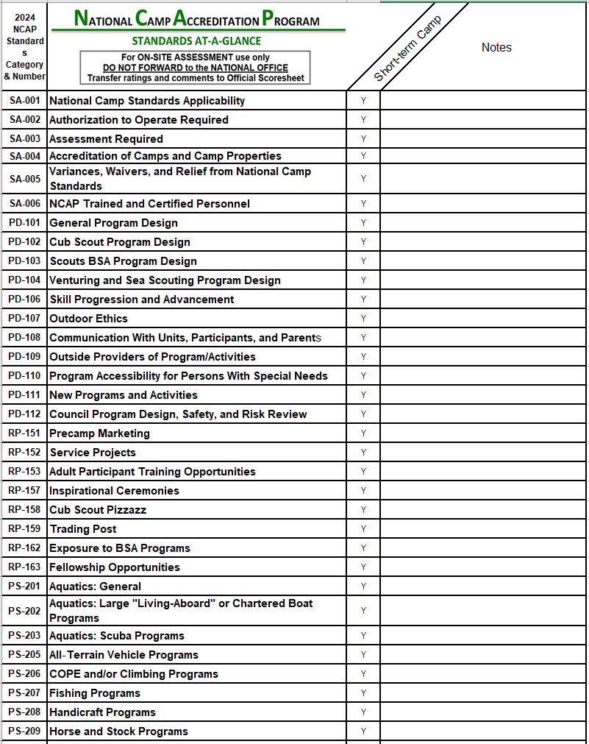

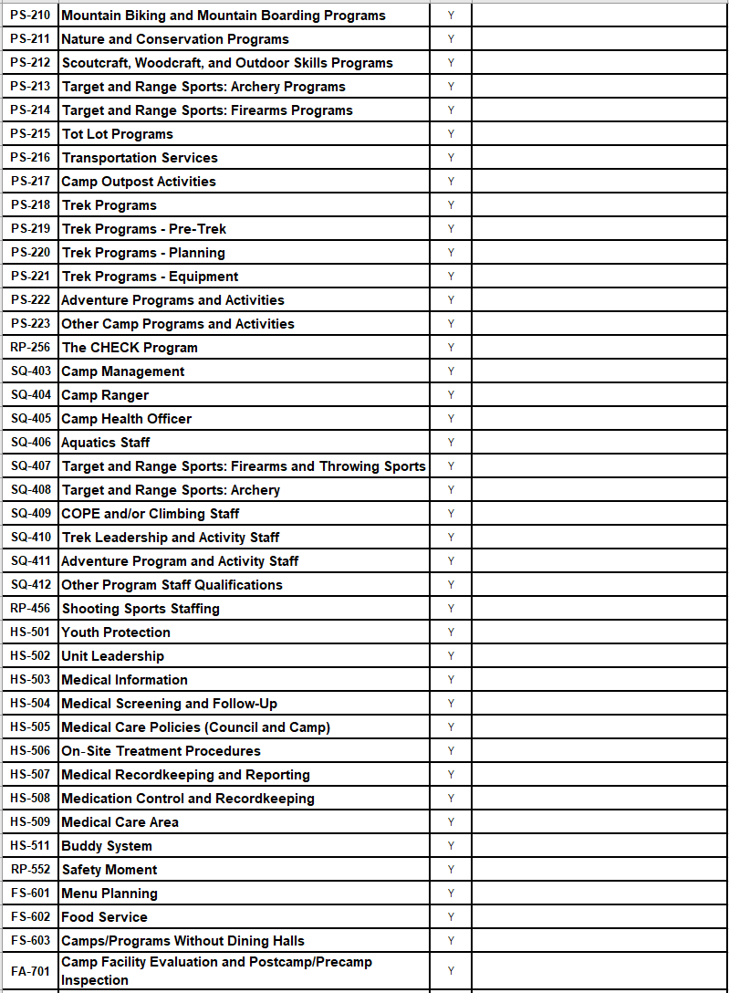

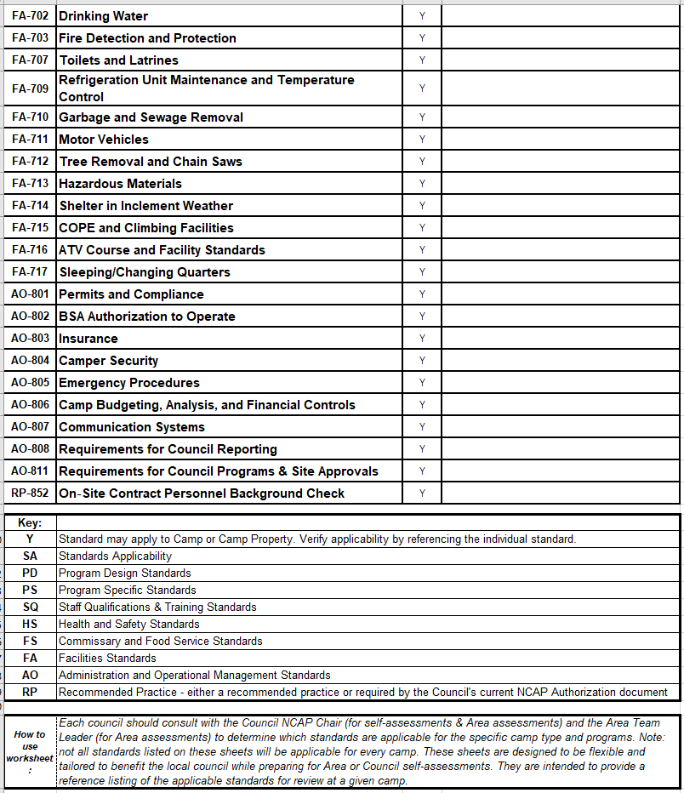

# Appendix E: Close-out Report Template

The event close-out report summarizes the event components in a concise format. It is to be filled out and submitted to the Council/District Activities Committee and to the Staff Advisor after the event is completed and all income and expenses have been collected.

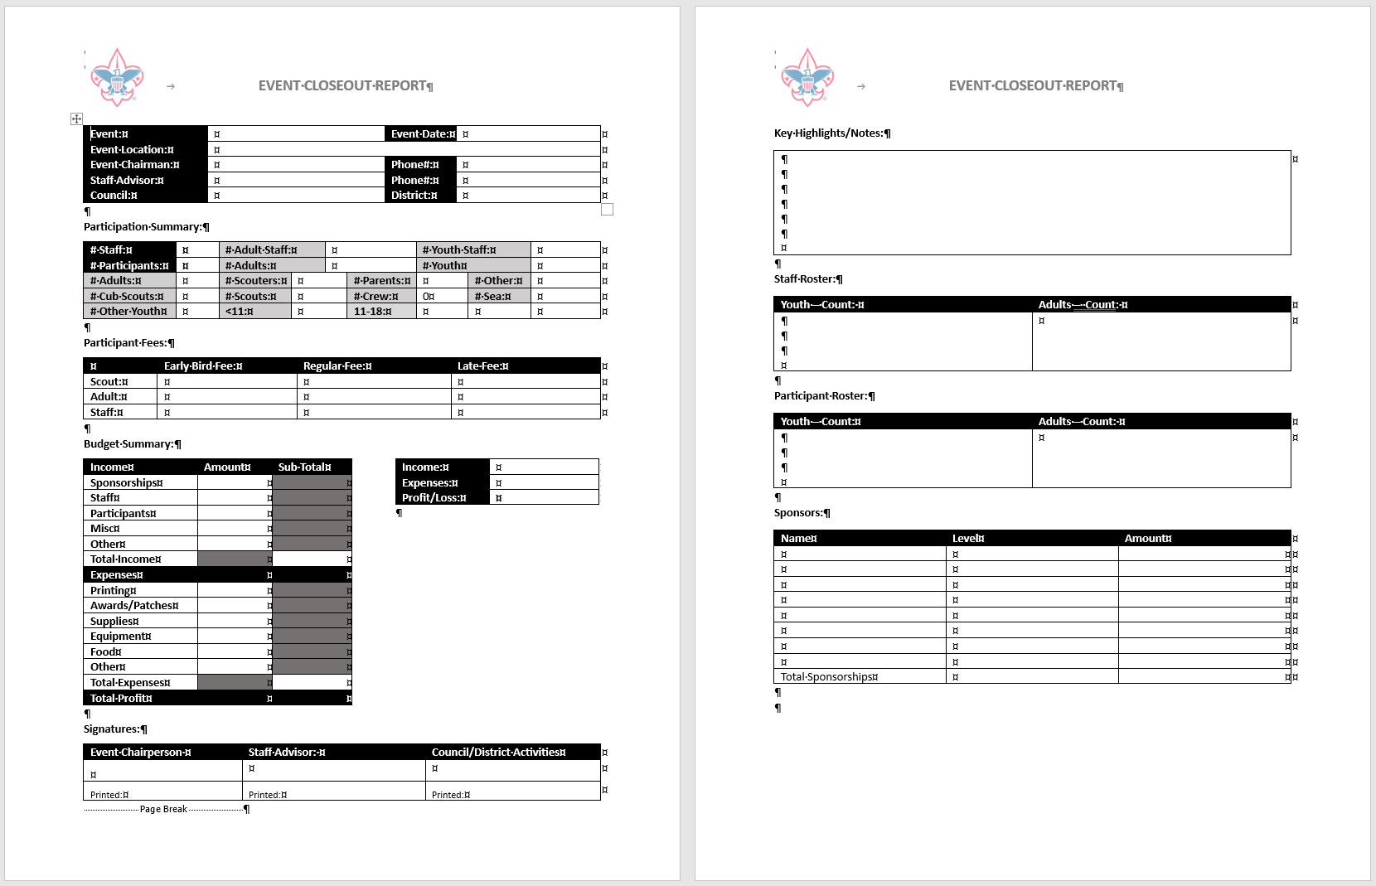

# Appendix F: Safety Guidelines

Scouting America’s Guide to Safe Scouting: <https://www.scouting.org/health-and-safety/gss/>

Incident Reporting website: <https://www.scouting.org/health-and-safety/incident-report/>

# Appendix G: Resources

2024 Short-term camp Standards at a Glance: <https://www.scouting.org/wp-content/uploads/2023/11/2024-NCAP-Standards-At-A-Glance-Short-Term-Camp.xlsx>

NCAP Short-Term Camp Planning Flowchart: <https://www.scouting.org/wp-content/uploads/2021/01/NCAP-Short-Term-Camp-Planning-Flowchart-2021.pdf>

BSA Ceremonies and Campfire Guidance: <https://www.scouting.org/wp-content/uploads/2021/04/NCS-Ceremonies-and-Campfire-Guidance-1.pdf>

Short-Term Camp Marketing Plan Primer: <https://www.scouting.org/wp-content/uploads/2024/04/STC-Marketing-Plan-Primer.pdf>

Short-Term Camp FAQ: <https://www.scouting.org/wp-content/uploads/2020/09/Short-Term-Camp-NCAP-FAQ.pdf>

Greater Tampa Bay Scouting Event and Activity Guide: <https://tampabayscouting.org/resources/event-and-activity-guide#1591648777616-5c6cbdac-f29a>

# Appendix H: Short-Term Camp Director Pledge

|  |  |
| --- | --- |
| Event Name: |  |
| Event Location/Dates: |  |
| Health Officer Name: |  |
| Short Term Camp Administration Name: |  |

I agree to abide by all of the guidelines set forth by the Scouting America and the Seneca Waterways Council. I understand that I am the camp director under the supervision of the Seneca Waterways Council. In addition to abiding by the Guide to Safe Scouting, the rules outlined by Scouting America and the council, I agree to the following:

* I will actively promote this event and work with my staff to increase attendance.
* If a ranger or council staff member asks that an activity stop that I will comply immediately.
* All participants and staff for the event will be registered through the online registration system and pay the proper fees before the event commences.
* My event will have a health officer with the proper training as outlined by SQ-405.
  + I will require all participants to have current health forms while attending the event. The forms may remain with the unit.
  + At registration, unit leaders will be asked if there are campers with health issues.
* My event will have a short-term camp administrator assigned to the event as outlined by SA-003 and SA-006.
  + This cannot be the camp director or a principal staff member of the event.
  + I will meet with them prior to the event to discuss and review the NCAP Local Council Authorization and Assessment Declaration Form. o If the event is not occurring at a council camp, I will arrange with them a pre-site inspection and complete the NCAP Site Appraisal Form.
  + I will meet with the administrator at the opening/beginning of the camp program for the assessment.
* I agree to following the SWC Event Safety Procedures:
  + Using wristbands to identify participants, staff and guests.
  + Give a safety brief at the beginning of the event that contains the information found in the sample safety brief located in the council emergency action plans.
  + Climbing, shooting, aquatics and kitchen staff are credentialed and approved by their respective committees and there is the appropriate number of staff present.
* I agree to the following Fiscal Procedures:
  + All expenses must be budgeted and preapproved by the staff advisor.
  + All out of pocket expenses must be preapproved in writing and be submitted with itemized receipts to get reimbursed.
  + Only council staff can bind the council to contracts or order items directly from vendors

|  |  |  |  |
| --- | --- | --- | --- |
| Camp Director Name: |  | | |
| Camp Director Signature: |  | Date: |  |
| Staff Advisor Signature: |  | Date: |  |